|  |
| --- |
| ISLAMIC UNIVERSITY OF TECHNOLOGYOrganization of Islamic CooperationBoard Bazar, Gazipur |

# Report on User Requirement Analysis

# Donors Choose

# CSE 4408

|  |  |  |
| --- | --- | --- |
| Fida Kamal | Fariha Fairoz Nohan | Alvi Aveen Khan |
| 180041208 | 180041214 | 180041229 |

**Table of Contents**

Methodology 3

Raw Data 4

Personas and Scenarios 5

Current Situations 7

Requirements 8

## Methodology

Questionnaires were used to collect data about user requirements.

The time available to collect data was very short, which is why questionnaires were preferred. They allowed the collection of a significant amount of data very quickly. Additionally, the risk of getting in contact with users physically during a pandemic was avoided.

The representative users consisted of anyone interested in making donations to charities. This category of users was chosen since the main goal of the system is to provide a convenient donation process.

## Raw Data

All users who were interviewed were positive that the suggested system would make the process of donating to charities easier for them. Nearly 50% of users felt that the existence of the system would motivate them to donate more often.

Over 80% of users said the main forms of donation they took part in were monetary donations and clothing donations. Of this, over 90% claimed to donate directly to people in their community instead of to a charitable organization.

When asked about the problems they were facing with the current system of donations, nearly 80% said that they were unable to even find a proper platform on which they could regularly make donations, while 96% admitted that the process of verifying the reliability of the available charities was arduous. 98% also cited difficulties gathering information about how to donate during national crises.

Amongst less serious problems, 95% of users mentioned an unfulfilled desire to stay up-to-date about charities they were interested in, while roughly 56% expressed a desire to be notified about the outcomes of their donations, something that is not currently available.

A handful of users mentioned other issues such as the difficulties of donating to more remote areas, and moral issues like the desire of certain donees to remain anonymous.

## Personas and Scenarios

Persona 1

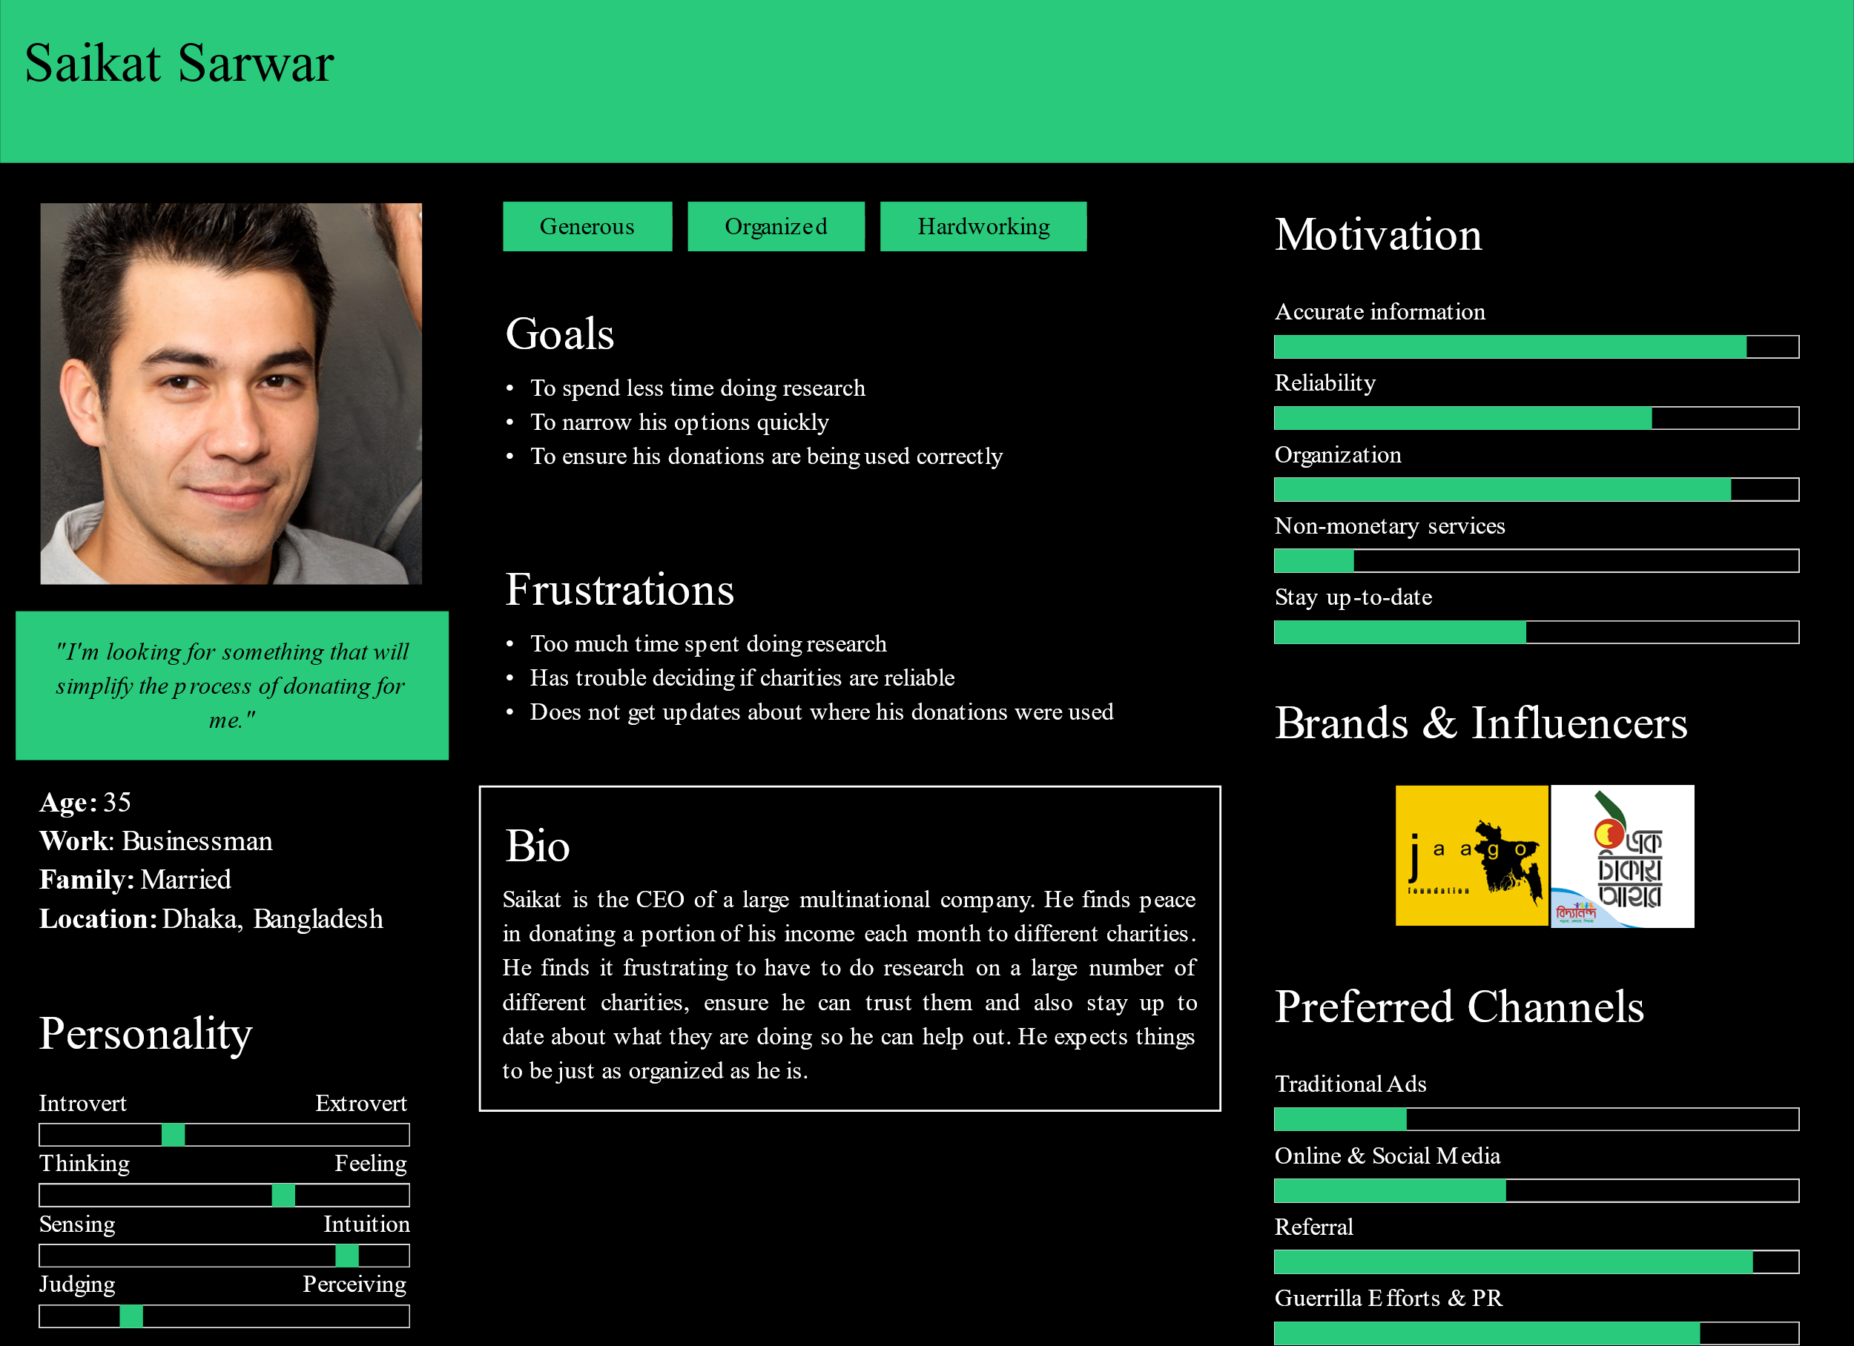

Scenario 1

Saikat is overwhelmed by all his commitments. He promised to donate a part of his income to different charities. Now he has to figure out what to do himself. As soon as he starts, he is irritated by the disorganization of most of the charity websites. He is not technologically competent, and is finding it difficult to navigate the sites. He also needs to comb social media pages of every single one to make sure he isn't being duped.

After hours of work, he manages to make a few donations. He hopes these were the right ones, but has no way to make sure. None of them offered any updates. Sadly, this is the best he can do.

Persona 2

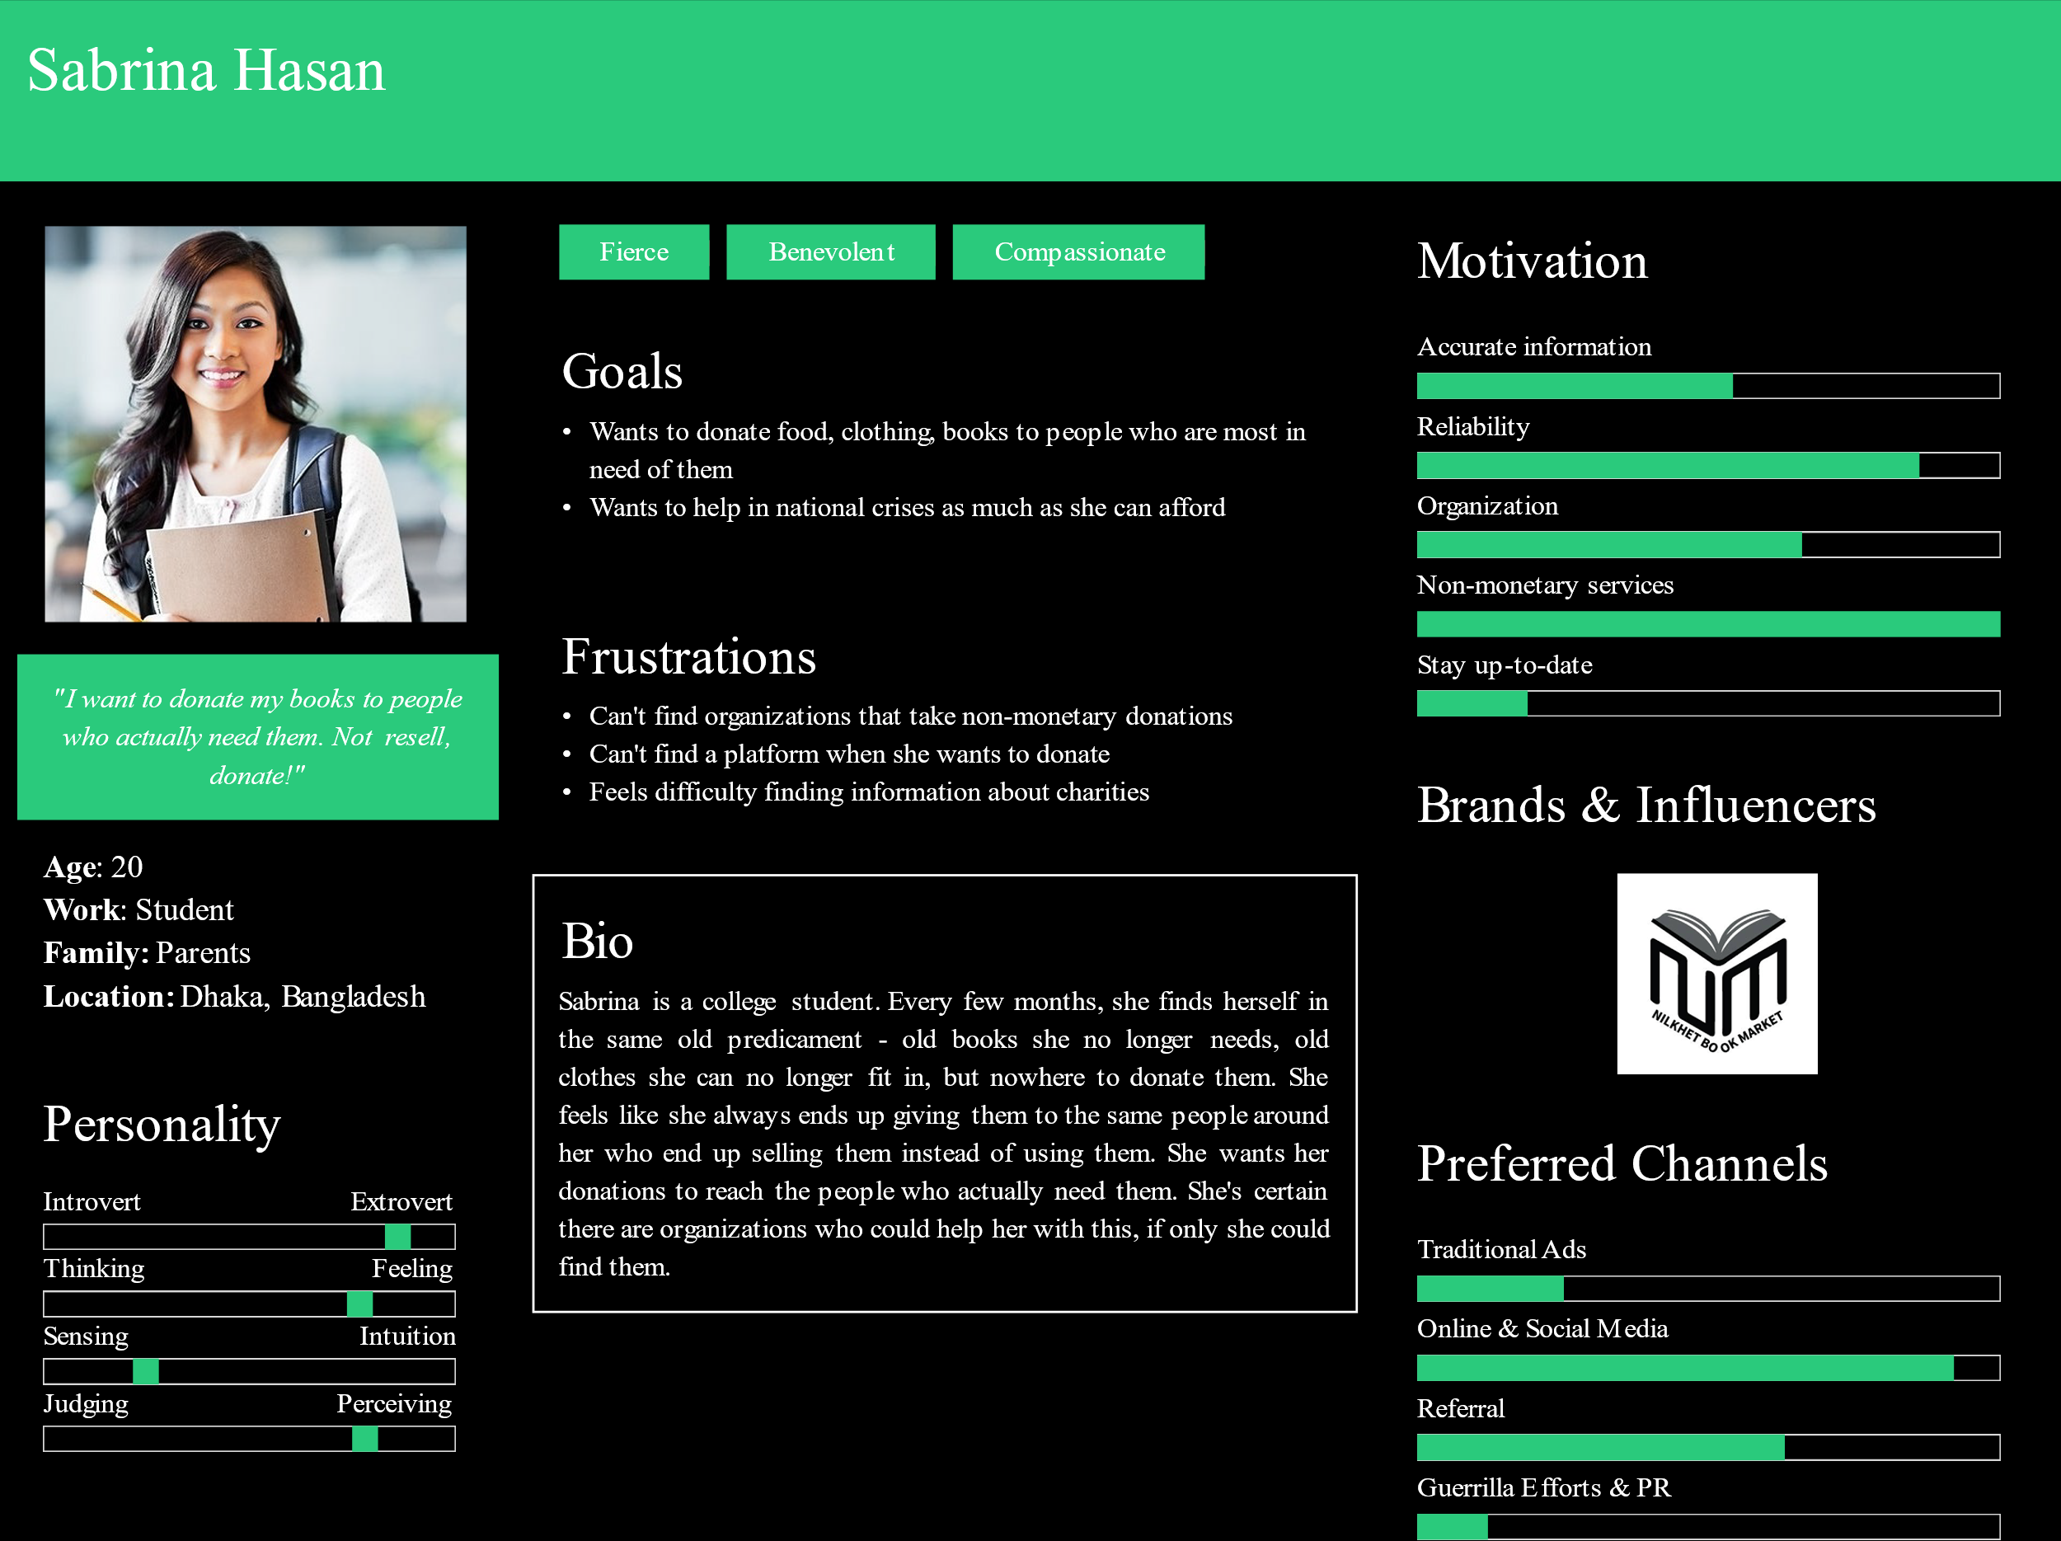

Scenario 2

Sabrina has finally gotten a break after her HSC exams. She decides it is time to clean up the mess she has made of her room. Combing through mountains of clothes, books and dust, she creates piles of all the books she no longer needs, and all the clothes she has outgrown. She asks her mother what she can do with this stuff, and is told to leave it by the door for the house help. Sabrina is certain giving them away to whoever is close by just means everything will be resold as second-hands. She wants her things to go to people who actually cannot afford to buy them.

Sabrina does some research, but it is not easy. Most charities highlight different ways to donate money, but not much else. In the end, she gives up as she fails to find a proper platform.

## Current Situations

A few organizations, like Jaago, have websites where donors can get the necessary information and donate money.

However, the donation methods and the information available is very limited. They do not take non-monetary donations for one, and the organizations that do usually do so through social media. Methods to stay up-to-date usually include keeping track of things via social media, and updates about the outcomes of donations are entirely unavailable.

There is no single platform where donors can find all the different kinds of charitable organizations.

## Requirements

The system must include separate profile pages for each charity that decides to use it. Users will be suggested these profiles based on the specific category of donations they are looking for, e.g. selecting clothing donations will show the profiles of charities that provide services to collect and donate second-hand clothes. These requirements arose from situations like the one described in the second scenario above.

Each profile will have user reviews prominently displayed to ensure users know that the charities they are donating to are trusted by others as well. Reliability is clearly an important issue to users, and this feature should definitely help in this regard.

During national crises, crucial information will be prominently displayed on the homepage of the program to guide users towards the charities that are doing the most work. Users reported such information being of great importance to them, and providing it prominently should satisfy the users.

Users who choose to donate to specific charities will be notified about what exactly was done with their donations. They will also be notified about upcoming events of charities they are interested in. A significant portion of the users expressed a desire to see such features, which is why they are being included.

There were also a few less popular suggestions, such as exchange services or services for start-ups, but since these were more individual requests than representations of the desires of the average user, and also because such features are not compatible with the motives behind this system, it has been decided that these features will not make it onto the final product.